Important MPU 9250 Notes

* The slave address of the MPU-9250 is b110100X which is 7 bits long. The LSB bit of the 7 bit address is determined by the logic level on pin AD0. This allows two MPU-9250s to be connected to the same I2C bus. When used in this configuration, the address of the one of the devices should be b1101000 (pin AD0 is logic low) and the address of the other should be b1101001 (pin AD0 is logic high).



# Frequency

Communication with all registers of the device is performed using either I2C at 400kHz or SPI at 1MHz. For applications requiring faster communications, the sensor and interrupt registers may be read using SPI at 20MHz.

Magnetometer normal operating current: 280μA at 8Hz repetition rate

Accelerometer Low Power Mode supports the following output data rates (ODRs): 0.24, 0.49, 0.98, 1.95, 3.91, 7.81, 15.63, 31.25, 62.50, 125, 250, 500Hz.

# Sampling Rates

DLPF = digital low-pass filter

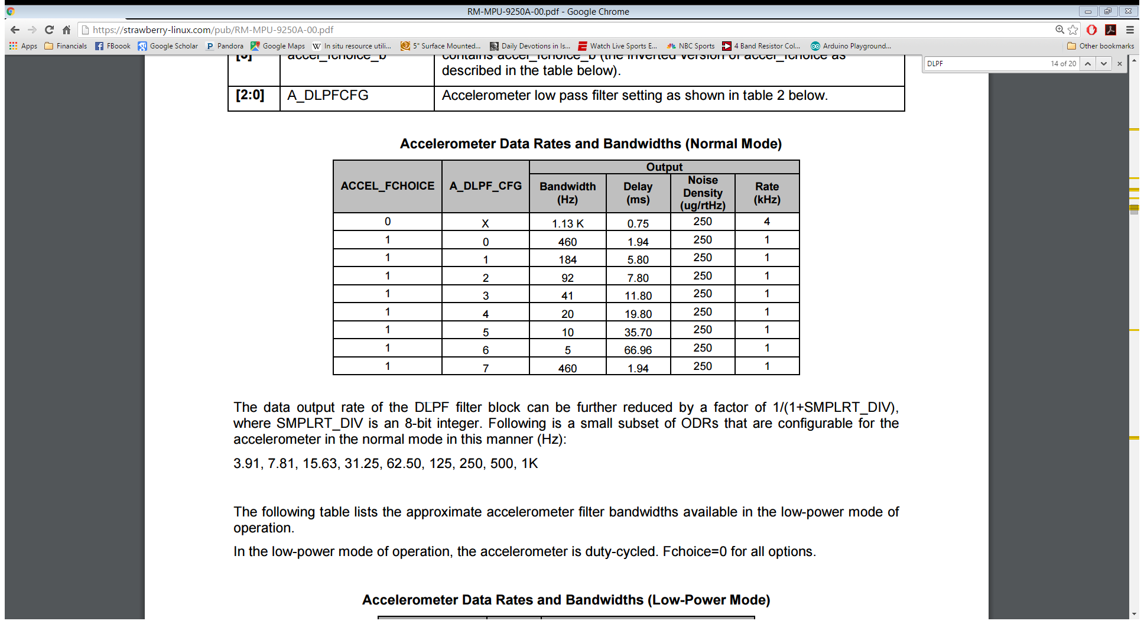

* A_DLPF_CFG = 3 (BW = 41 Hz) (sampling rate > 82Hz)
* ACCEL_FCHOICE = 1
* Delay = 11.8ms (sampling rate < 84 Hz)

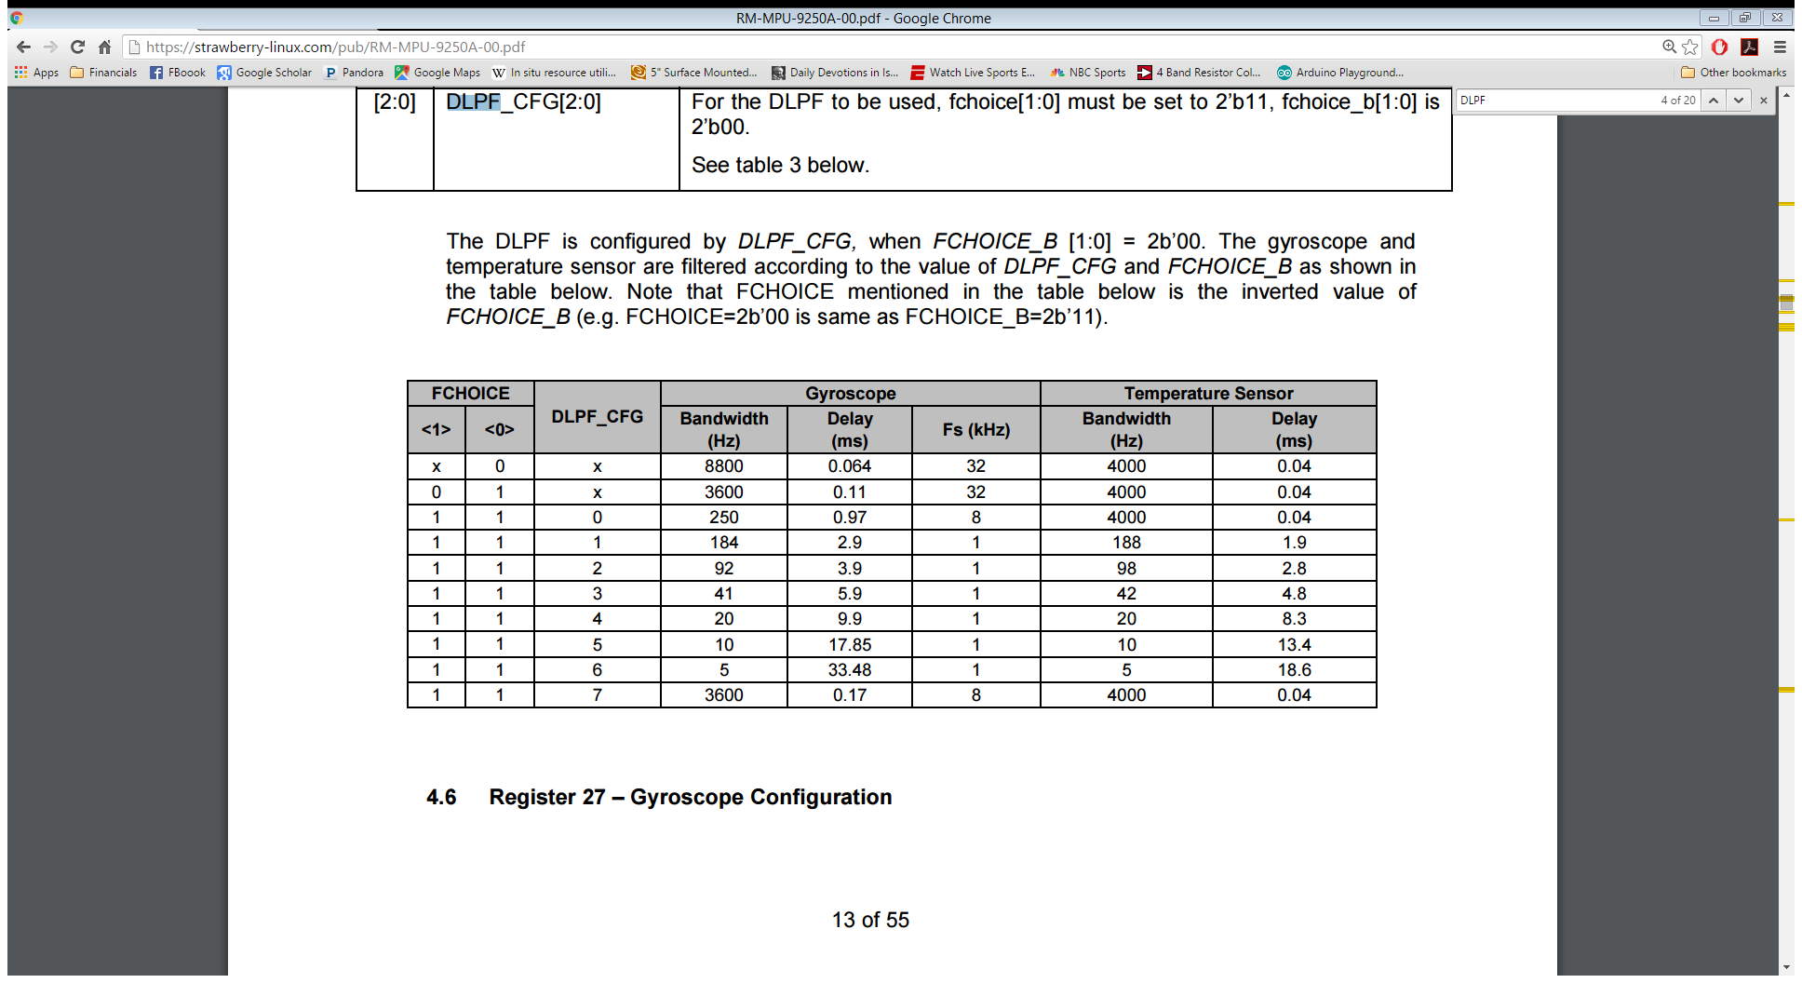

DLPF_CFG = 3 (41 Hz) (sampling rate > 82 Hz)

FCHOICE = <1><1>

Delay = 5.9ms (sampling rate < 169 Hz)

# Magnetometer

Output data resolution:

* 14-bit (0.6 µT/LSB)
* 16-bit (0.15 µT/LSB)
* Measurement range: ± 4900 µT
* Average current at 8Hz repetition rate: 280µA typ.

AK8963 has the limitation for measurement range that the sum of absolute values of each axis should be smaller than 4912μT.

* |X|+|Y|+|Z| < 4912μT

# I2C Master Clock speed

